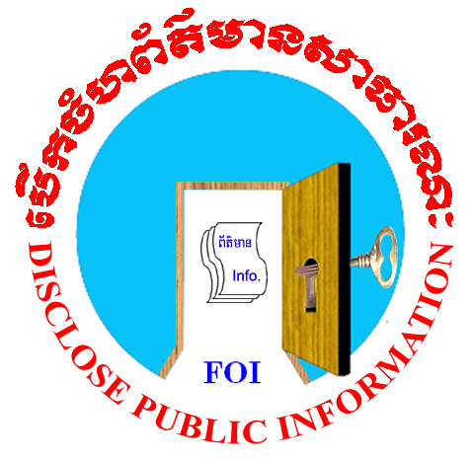

Review
of the Draft Policy Framework
on
Access to Information of Cambodia


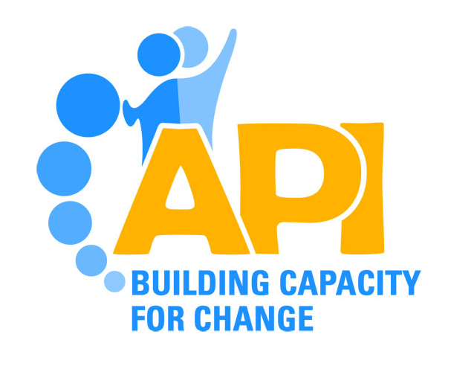
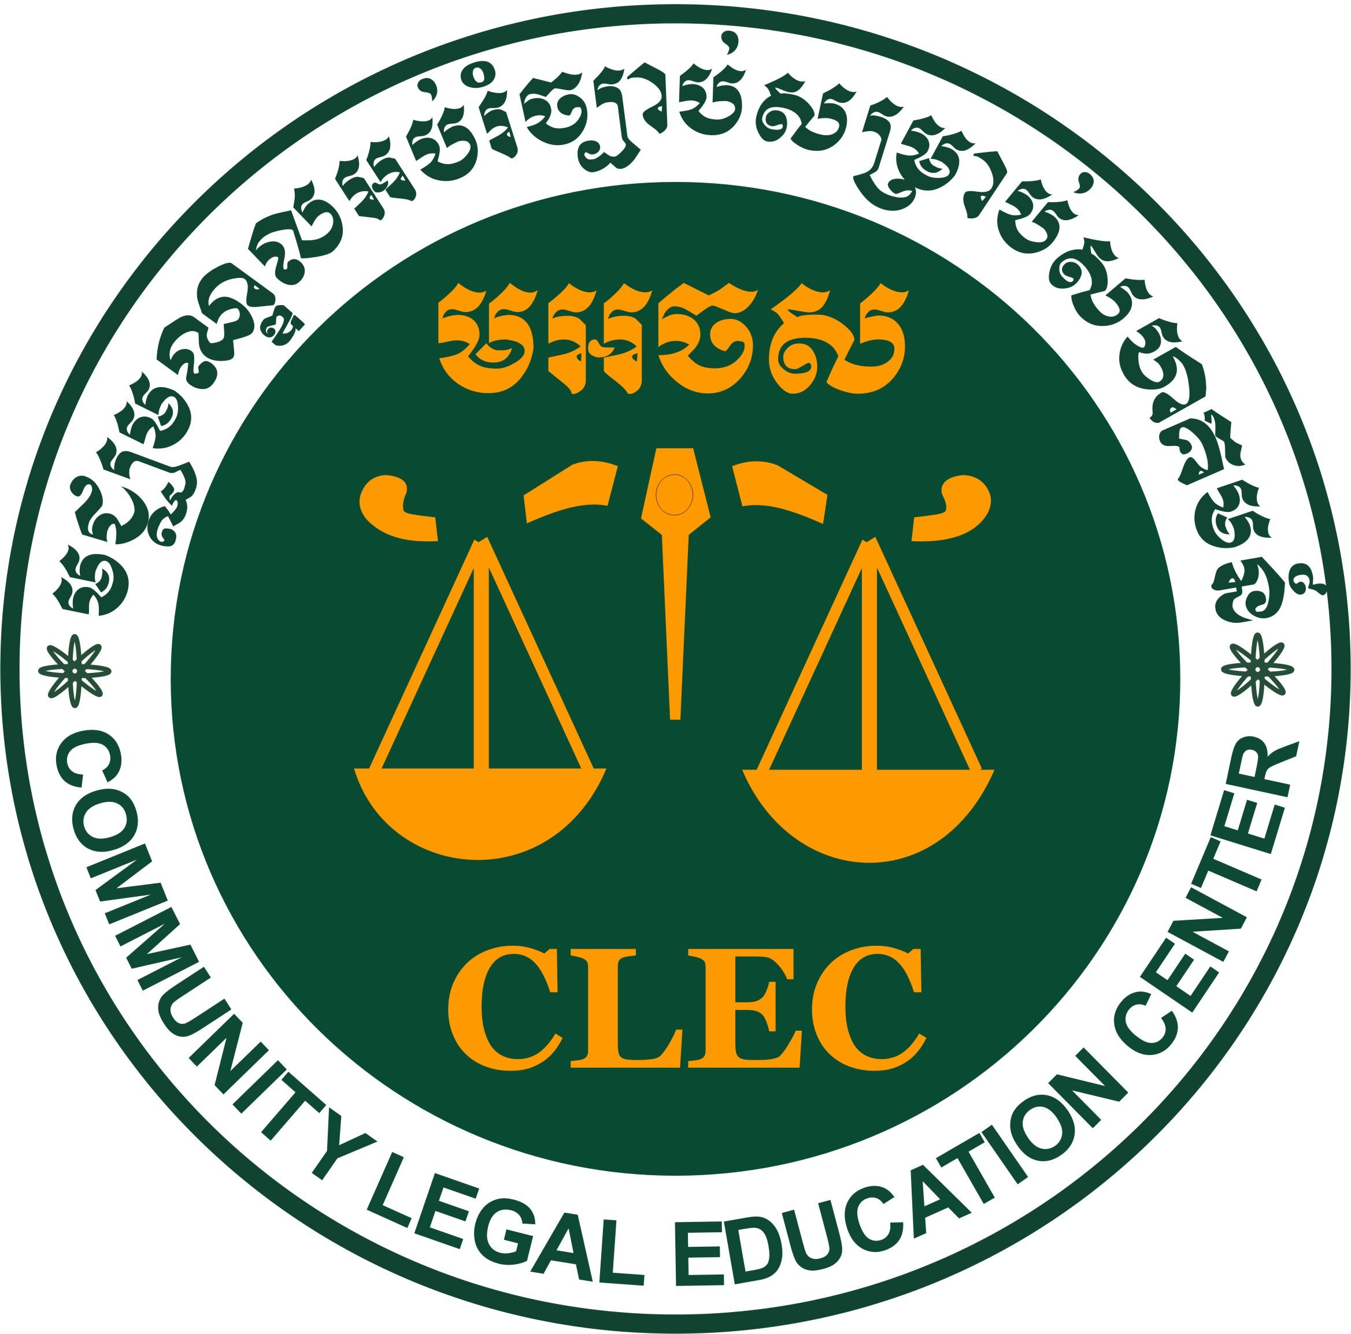

October 2011

CONTENTS

About Freedom of Information Working Group
3
Summary of recommendations 4
Section 1 Introduction 5
Section 2 Objective of Access to Information Policy 6
Section 3 Target of Access to Information Policy 8
Section 4 Exemptions Balancing Protection and Access 10
Section 5 Procedures for Accessing Information 11
Section 6 The Appeal process and an Information Commissioner 12
Section 7 The Next Steps 13

About Freedom of Information Working Group

The Working Group has started its work since late 2003 and in January 2005 the Working Group was formally established as Freedom of Information Working Group (FOI Working Group). It was formed in 2003 with nineteen members, who are national and international organizations.

The objective of the Working Group is to promote the right to access the information in Cambodia. So far the Working Group has done a lot of works such as national workshops on access to information, workshop on access to information in conjunction with the Senate, consultative forums on access to information, training and awareness raising on access to information, publication and radio program on access to information, and legal study and analysis on Cambodia’s laws relating to access to information and so on.

If you would like to discuss this further, or if you have a matter you would like to bring to the attention of the FOI working Group, you can contact the Representative of Working Group by address:

Mr. Sinthay Neb
API Director, the Freedom of Information Working Group representative

Phnom Penh villa, Building 124, 2nd Floor, Room 206, Toul Svayprey I,
Khan Chamkarmorn, Phnom Penh, Kingdom of Cambodia
Tel: (855-23) 213 486 or (855-77) 555 679
Email: apioffice@apiinstitute.org or sinthayneb@apiinstitute.org
Website: www.apiinstitute.org

Summary of Recommendation

- Keep the whole Section 1 of the draft policy framework on access to information as it is, especially 9 principles of the ARTICLE 19.
- Keep the whole Section 2 of the draft policy framework on access to information as it is.
- Keep the whole Section 3 of the draft policy framework on access to information as it is, except sub-sections 3.4 and 3.5.
- For sub-section 3.4, a heading of sub-section in Khmer version, which reads Information covered Access to Information should be amended to ‘Information covered by Access to Information’.
- A clause “ Although the occurrence, event or matter which has taken place before the date on which the law on access to information was adopted, in case the request is made for the information and there is no record, the government should create the record for that request ” should be added to the content in sub-section 3.5.
- Keep the whole Section 4 of the draft policy framework on access to information as it is.
- Keep the whole Section 5 of the draft policy framework on access to information as it is, except sub-section 5.7 on fee, which should be amended.
- The sub-section 5.7 should provide that the fee apply only to the cost of reproduction of information and if necessary posting the copy to the requestor, and not the information and the submission of requests.
- Keep the whole Section 6 of the draft policy framework on access to information as it is and add new paragraphs on establishing Access to Information Tribunal and its duties and functions.
- Add to the Section 6 of the draft policy the last mechanism of the appeal, i.e. when the case could not be solved at the Access to Information Tribunal, a party can lodge an appeal against the Tribunal’s decision with the Supreme Court.
- Keep the whole Section 7 of the draft policy framework on access to information as it is.

Introduction

The Cambodian Government views good governance as a core and essential component of rectangular strategy to achieve the development goal. Access to information is a crucial ingredient in achieving key goal of good governance. It allows people to acquire Government held information and for the Government to operate with more transparency and accountability. To promote transparency and accountability, an Access to Information Law is necessary for Cambodia. Such a law would helps to encourage trust and confidence between the Government and Cambodian people. It would empower and encourage more people to engage with the political and development processes that contribute to the sustainable development.

The Freedom of Information Working Group have been working on this for years, especially, in cooperation with the Royal Government, has worked rigorously to support for the Access to Information Law. In the process of Access to Information policy framework development, the Working Group has sent its 2 members, on behalf of civil society, to observe this process done by the drafting team of Ministry of National Assembly, Senate Relations and Inspection.

So far the evolution of the society has been changed and Anti-Corruption law was passed. With the official meeting with representatives of MoNASRI, led by H.E.Tuot Lux on 4 March 2011, to discuss on the status of policy framework and the next cooperation, the MoNASRI expressed the intention to move forward on this draft policy framework. Hence, the working Group see that it is very important to review and comment on the access to information draft policy framework which will be useful asset when the MoNASRI start finalising on it. The review was led by CLEC with relevant legal background members representing ADHOC, API, CCHR, CHRAC and Star Kampuchea and was financially supported by CLEC and DANIDA through API. In addition, this review and suggestion were consulted in a national workshop with all relevant stakeholders and incorporated inputs from provincial consultative forums.

The objective of this review of the Policy Framework is to examine the draft and compare it with model law and best practices on access to information in order to assess whether the draft policy framework is a progressive that will enhance free flow of information and democratic governance in Cambodia. This review is also aimed to give recommendations to the Royal Government of Cambodia in order to assure that the policy framework on access to information become a fundamental and comprehensive guideline for drafting the law on access to information.

The Policy Framework Review

Section 1: Introduction

The introduction of the draft policy framework on access to information indicate that “The Royal Government of Cambodia promotes the drafting of an access to information policy for the purpose of strengthening the state of law and democracy particularly human rights in Cambodia”. The introduction of the draft policy also indicates that “All Cambodian citizens should have the right to access government-held information as required by law”. This clause of the introduction is good because it is similar to the principles of access to information law of the countries in other regions which state that the right to information is the human rights. The introduction of the draft policy also includes 9 principles of rights to access to information from the ARTICLE 19 (sub-section 1.4.1). The draft policy also provides that “The Drafting Team has taken into account the Cambodian context in applying these principles throughout the Policy Paper”. This is one of the positive aspects of the draft because the inclusion of 9 principles of the ARTICLE 19 into the draft will likely lead to the draft law on access to information that meet international standard and based on best practices from other countries.

Aside from important aspects relating to human rights, democracy, and international standard and best practices in access to information, the introduction of the draft policy presents the Cambodia’s context relating to access to information. The introduction says “An access to information law within the Cambodian context therefore needs to be evolutionary and developed in partnership between the government of Cambodia and its citizens”. Another important aspect of the introduction of the draft policy is the balance between accessing and protecting information. The introduction says that “ This Policy Paper promotes a balance between accessing and protecting important government information”.

The inclusion of Cambodia context in the draft policy is very important because it helps the future drafting team of Law on Access to Information to have broader insight for the inclusion of international standard and best practice into the Draft Law on Access to Information of Cambodia. Also the inclusion into the draft policy of the balance between accessing information and the protecting government information will likely help the law drafting team to properly consider the exemption of the information disclosure before including them into the draft law.

Recommendations
- Keep the whole Section 1 of the draft policy framework on access to information as it is, especially 9 principles of the ARTICLE 19.

Section 2: Objective of Access to Information Policy

In this section, the draft policy framework on access to information is divided into the following sub-sections: the objectives of Access to Information legislation, what is public access to information, and the need for a national information policy.

The objectives of Access to Information legislation (sub-section 2.1 of the draft policy)
The draft policy presents the objective of the law on access to information first before providing the argument on the objective of the drafting policy framework on access to information. The draft policy says that the objectives of the access to information law “ First, it will empower people, giving everyone a legal right of access to the information that they want to see as defined by the Law. Secondly, it will place statutory duties on the bodies covered by the Law to make certain information publicly available as a matter of course”.

The draft policy says that A clear policy framework will ensure that an Access to Information Law, and any subsequent legislation will assist the Royal Government of Cambodia to:

- Convert Articles 31, 35 and 41 of the Constitution of the Kingdom of Cambodia into practical rights for all Cambodians;

- Assist in achieving the objective of Good Governance under the Rectangular Strategy;

- Assist in achieving the Cambodian Development Cooperation Forum target of a well functioning transparent and accountable legal and judicial system that protects individual rights as defined in the Constitution of the Kingdom of Cambodia;

- Satisfy the specific Cambodian Development Cooperation Forum requirement for a clear Policy Framework on Access to Information as part of Target 17 of the Joint Monitoring Indicators (June 2007);

- Lead to legislation that, in partnership with the proposed Anti-Corruption Law and other transparency policies, will be of lasting benefit to Cambodian democracy;

- Support adequate information and records management practices that will aid in improved policy making and service delivery for the benefit of all Cambodians;

- Inform the public, including organizations, companies, civil servants and the media, about the Government’s activities and operations, including how decisions are made;

- Encourage people to participate actively in the political process and decision-making;

- Assist the community to monitor and ensure that public funds are being spent as intended and effectively;

- Reduce unnecessary secrecy in government;

- Promote the human rights of all Cambodians.

All objective the access to information law will help the Royal Government of Cambodia to achieve are in the international standard and best practices in the region and in the world relating to access to information, human rights and the promotion of democracy.

What is Public Access to Information? (sub-section 2.2 of the draft policy)

This sub-section seems to give the definition of “ public access to information”. In fact this section of the draft policy only restates the article 19 of the 1948 UN universal declaration on human rights, article 31, 35 and 41 of Cambodian constitution and all these are related to access to information. However this is not the problem because the public access to information is described in detail in sub-section 3.1 of the draft policy.

The need for a national information policy (sub-section 2.3 of the draft policy)
The draft policy indicates that The way institutions and society manage the access to, and protection of, information is a critical catalyst in the creation of good governance, the efficient and effective delivery of services to all including the poorest and most disadvantaged and the strengthening of democracy. The draft policy also indicates that a government based on secrecy leads to corruption and waste, which are weak foundations for an effective government.

Furthermore, the draft policy indicates that “ this Policy Paper on Access to Information is the foundation stone for the national information policy and Access to Information legislation is an important and necessary component in a wider policy program to ensure that Cambodia is well positioned to participate in the information age. Investors and foreign governments will place more trust in a Cambodian government that is transparent”. The draft policy also indicate that “a long term national information policy will need to be developed by the Royal Government of Cambodia in the future”.

The inclusion into the draft policy of the need for a national information policy for Cambodia and the willingness of the Royal Government to develop a national information policy is another important aspect of the draft policy’s objectives. Why is it important? Because having a broad and clear national information policy will not only determine a regime of access to information law but also the degree of transparency, accountability and participation of the people in the national development.

Recommendations
- Keep the whole Section 2 of the draft policy framework on access to information as it is.

Section 3 Target of Access to Information Policy

The Right of Public Access to Information (sub-section 3.1 of the draft policy)
In this sub-section there is no definition of ‘public access to information’ but it attempts to explain that “The ability of the public to access information held by public authorities in Cambodia should be a legally enforceable right”. There is also an explanation that “In order to exercise that right, a member of the public should be able to request and quickly receive access or a decision justifying why access to government-held information was not granted”.

Who Can Access Information? (sub-section 3.2 of the draft policy)
This sub-section of the draft policy states that “some older versions of access legislation impose such restrictions but most modern Access to Information laws make access universal”. This is one of the positive aspects because granting access to information to those who live outside a country jurisdiction not only promotes the free flow of information but also helps that country to gain benefits such as attracting foreign investment.

The scope of bodies covered by a right to access information (sub-section 3.3 of the draft policy)

This sub-section of the draft policy provides that under the access regime proposed for the Royal Government of Cambodia, the public would have the right to information held by:

- Bodies that are established by or under the Constitution of Cambodia;
- Bodies that form any part of any level or branch of government, such as Ministries and local authorities
- Bodies that are, controlled or substantially funded by the Government
- Bodies that carry out a statutory or public function
- Bodies contracted by a public body to undertake a statutory duty or public function on its behalf.

The inclusion into the draft policy of type of institution covered by the right to access to information is more comprehensive than just the use the word ‘public institution’. Some Access to Information laws or policies says that “the public has the right to access the information held by public institutions” and this excludes private institutions ( such as private companies) that make contracts with the government from the coverage of access to information law.

Information covered by Access to Information (sub-section 3.4 of the draft policy)
This section of the draft policy says “All public institutions should be subject to the Access to Information law and only certain information held by those institutions should be excluded from the operation of the legislation...”.

This seem a little bit short but that’s not the problem since some information not covered by the Access to Information law is discussed in the exemption in Section 4 of the draft policy. However, the sub-section 3.4 of Khmer version of the draft policy is incorrect; it reads ‘Information covered Access to Information’. Therefore, the Working Group suggest that Khmer word ‘dauy’ which is equivalent the English word ‘by’ should be added to the phrase so that the new phrase would read ‘Information covered by Access to Information’.

No Retrospective Application (sub-section 3.5 of the draft policy)

This section of the draft policy states that “Access to Information legislation should only apply to information created after the date that the legislation is passed”. The draft policy takes the high cost for reproduction of information as the reason for not having retrospective application.

This clause of the draft policy may weaken the principle 2 of the access to information- obligation to publish. If the requesters need the information that has taken place 1 day before the law on access to information was passed and the respective information was not published by the government, they would likely to lose the access to information. Therefore, the Working Group thinks that there should be the exception for not having retrospective application. We would like to suggest that “ although the event or matter has taken place before the date the Access to Information law was passed, when there is the request for the respective information which was not published, the government should produce that information”.

Decision-making (sub-section 3.6)

This section of the draft policy provides the appointment of Information Officer and the designation of power for decision making on the release of public information. This is another positive aspect of the draft since it meet the principle 5 of access to information - processes to facilitate access.

Partial Disclosure of information (sub-section 3.7)

The argument that part of classified information should be disclosed is another attempt to promote the maximum disclosure which is the principle 1 of the access to information.

Proactive disclosure (sub-section 3.8)

This sub-section of the draft is another positive aspect since it promotes the principle 1 of access to information - the maximum disclosure.

Protection of whistleblowers (sub-section 3.9)

This sub-section of the draft policy says that “ individuals should be protected from any legal, administrative or employment-related sanctions for releasing information on wrongdoing”. The Working Group also think that this is also another positive aspect of the draft policy since it this sub-section promotes the principle 9 of access to information.

Recommendations
- Keep the whole Section 3 of the draft policy framework on access to information as it is, except sub-sections 3.4 and 3.5.
- For sub-section 3.4, a heading of sub-section in Khmer version which reads Information covered Access to Information should be amended to ‘Information covered by Access to Information’.
- A clause “ Although the occurrence, event or matter which has taken place before the date on which the law on access to information was adopted, in case the request is made for the information and there is no record, the government should create the record for that request ” should be added to the content in sub-section 3.5.
Section 4: Exemptions Balancing Protection and Access

The important point of this section of the draft policy is the presentation of reasons relating to the release and protection of information in the general principle (sub-section 4.1). It is worth to note that the first paragraph of the section provides that “Access to information schemes create clear, rational and consistent guidelines for the handling of public information. The presumption is that any piece of information can be released to the public. However, if the release of information would be harmful, and the harm outweighs the public interest in openness, then the information may be withheld. To outweigh the public benefit, the harm must be substantial damage to a particular, specified interest”.

Sub-section 4.3 of the draft policy says that ‘access to Information law rarely defines the precise meaning of the public interest because it varies depending on the facts, the context and the circumstances of each case’. This another aspect of the draft policy which is flexible enough as too rigid definition of the ‘public interest’ would regard some cases as not public interest.

Even though there is no specific definition on ‘public interest’ the draft policy points out some factors which is considered public interest (sub-section 4.4). These factors are:

- Effective decision-making and accountability;
- Ensuring that a public body is adequately discharging its functions;
- The effective use and oversight of public funds;
- Debate on issues of public interest;
- Public participation in the political process and decision-making;
- Public safety and public health;
- Protection of the environment.

Proposed Exemptions for Cambodia (sub-section 4.5 of the draft policy)

The proposed exemptions are adapted from Information Disclosure Policy: A Toolkit for Pacific Governments July 2006. They are:

      - Where disclosure would be reasonably likely to cause serious harm to national security, defense, international relations, the national economy;
      - Where disclosure would be reasonably likely to cause serious prejudice to the effective formulation, development or delivery of government policy.
      - Where disclosure would be reasonably likely to cause serious prejudice to the investigation or prosecution of a crime or the ability to conduct a fair trial, would constitute a contempt of court, is forbidden to be published by a court or tribunal or would facilitate an escape from legal custody;
      - Where disclosure would constitute a breach of any relationship recognized by law;
      - Where disclosure would endanger the health or safety of any natural person;
      - Where disclosure would seriously prejudice the legitimate commercial or competitive position of the public institution or a third party or cause unfair gain or loss to any person or the information was obtained in confidence from a third party and it contains a trade secret protected by law;
      - Where disclosure would constitute an unreasonable invasion of privacy of a person who is not a government official or where the information is about a government official but has no relation whatsoever to their official position or duties.
Regarding the proposed exemption for Cambodia the Working Group considers that it is acceptable because it is not only adapted from a Toolkit for Pacific Governments regarding the information disclosure policy but also meet the best practices regarding the exemptions of information in advanced democracies in the world. All proposed exemption in this draft policy are well and clearly explained and advised. Regarding these above-said exemption, the draft policy also mentions that many Access to Information laws provide for an exhausted list of secrecy clauses in other legislation, and require that these clauses should or should not exempt from the application of access to information legislation.

Recommendations
- Keep the whole Section 4 of the draft policy framework on access to information as it is.

Section 5: Procedures for Accessing Information

The draft policy indicates that the procedures for requesting and accessing information should be designed to be easy for public servants to administer and simple and accessible to the public to use and understand (sub-section 5.1 of the draft policy). The procedures talk about the promotion of proactive disclosure, means of communication for request for information, proper measures to assist the requester, steps to deal with requests that are made to the wrong department, and the duration for acknowledgement and response to the request. From the Working Group’s point of view the procedures for accessing information in this draft policy is generally positive since they are similar to those of the access to information law model.

In addition, the draft policy also includes provisions such as methods of responding to requests (sub-section 5.2), extension of requests (sub-section 5.3), dissatisfaction with the outcome of a request (sub-section 5.4), refusal to provide information (sub-section 5.5), vexatious or voluminous requests (sub-section 5.6), and minimal fees (sub-section 5.7). Regarding the fee, the draft policy says there should be minimal fees and waived for users who are poor. However, the draft policy suggests that the fees should apply to application and reproduction of records. The Working Group thinks that to promote the access to information, especially the promotion of principle 5 (processes to facilitate access to information), fees should apply only to reproduction of records and if necessary posting the copy to the requestor, and not to the information and the submission of requests.

Recommendations
- Keep the whole Section 5 of the draft policy framework on access to information as it is, except sub-section 5.7 on fee which should be amended.
- The sub-section 5.7 should provide that the fee apply only to the cost of reproduction of information and if necessary posting the copy to the requestor, and not the information and the submission of requests.

Section 6: The Appeals Process and an Information Commissioner
Section 6 of the draft policy provides the need for an effective appeals process (sub-section (6.1), third party rights and appeals (6.2), information commissioner (6.3), appoint- ment of the information commissioner (6.4), functions of an information commissioner (6.5),
accountability of the information commissioner (6.6), and powers of the information commissioner (6.7). These sub-section of the draft policy are positive and promote the access to information.

As for the roles of the information commissioner, the draft policy indicates three roles. First, deciding appeals about denied access to information requests or fee charges and responsibility for the oversight of the public access to information regime. Second, an Information Commissioner would review and make recommendations about any amendments to the access to information law. Third the information commissioner would be responsible for raising public awareness about public access to information and provide training to the civil service. The Working Group thanks that first and second roles of the information commissioner in this draft policy conform to the 9 principles of the access to information of the ARTICLE 19 whereas the third role of the information commissioner in this draft policy is more than what is in all 9 principles of the ARTICLE 19.

Regarding the appointment of the Information Commissioner (sub-section 6.4), the draft policy mentions about the careful process for selecting the Information Commissioner and independence of that institution. The draft also resents 9 functions of the Information Commis- sioner (sub-section 6.5), including the investigating complaints, enforcing compliance,... giving recommendations to public authorities, and disseminating information about the Access to Information law. As for the function of the Information Commissioner, which is mentioned in the draft policy, the Working Group thinks that it is another attempt to have an institutional framework that assures the effective implementation of the right to access the information.

Beside the mention about mechanism to ensure the accountability of the Information Commissioner (sub-section 6.6) the draft policy also says about the power of the suggested body (sub-section 6.7). The draft policy states that in relation to investigating complaints that authorities have not complied with any of the Access to Information Law, the Commissioner should have the power to assess: the level of fee sought by the state institution, the response to the request within the time limits imposed by the Act, whether state institution has disclosed the information in the form in which the applicant sought it,... and whether the institution has correctly withheld the information sought, either because it was properly exempt from the obligation to disclose or because the balance of public interest favored withholding it. In addition the draft policy mentions about powers the Information Commissioner needs to discharge their functions in relation to investigating complaints. Those include the power to require a public authority to supply the information relevant to the request, plus a report from the state institution on why it withheld the information; the power to enter and search the premises of the state institution if the Commissioner decides that the state institution has not supplied the information sought or the Information Commissioner suspects that the state institution has destroyed the information sought.

We think that the fact that the draft policy says that the Information Commissioner should have enough power necessary to discharge their functions is another positive attempt to implement the Access to Information Law effectively as well as to ensure the effective exercise of the right to access the information.

However, the Working Group think that only Information Commissioner cannot ensure the effective implementation of right to access the information. When the case could not be solved by the Information Commissioner, there would no way for next appeal. In some countries such as the UK and Thailand, the creation of Access to Information Tribunal is included into the Law on Access to Information. The Tribunal has power to decides appeals against the Commissioner’s decisions. The Working Group would like to suggest that the idea of creating Information tribunal should be included into this draft policy. The Working Group would like also to suggest that to ensue the effective implementation of access to information, another mechanism relating to the appeal process, that is the appeal to supreme court, should be included in this draft policy. The parties involving the case in the Information Tribunal can make an appeal against the decision of the Information Tribunal to the supreme Court.

Recommendations
- Keep the whole Section 6 of the draft policy framework on access to information as it is and add new paragraphs on establishing Access to Information Tribunal and its duties and functions.
- Add to the Section 6 of the draft policy the last mechanism of the appeal, i.e. when the case could not be solved at the Access to Information Tribunal, a parties can lodge an appeal against the Tribunal’s decision with the Supreme Court.

Section 7: The Next Steps
Generally, section 7 of the draft policy talks about the works to be done following the adoption of the draft policy by the Royal Government of Cambodia. The works include the capacity such as creation of the Information Commissioner (sub-section 7.1.1), training of access to information decision maker (7.1.2), records management (7.1.3), international conference (7.1.4); and the implementation.

The important point worth to be noticed in Section 7 is the drafting Access to Information Law and Implementation. Regarding the drafting Access to Information Law, the Section 7 says that “The drafting of an Access to Information law should be relatively quick given the knowledge and expertise accumulated during the drafting of this draft Policy Paper. Furthermore there are many international examples, including the Article 19 Model Law (Annex 7) to offer guidance...” A positive aspect of the Section 7 is the suggestion that while there will need to be adjustments made to adapt this law to Cambodia there should be little difficulty in drafting the law.

Recommendations
- Keep the whole Section 7 of the draft policy framework on access to information as it is.

The FOI working Group members: ADHOC, API, CCIM/VOD, CDCam, CEDO, CHRAC, CLEC, COMFREL, CSD, Equal Access, KID, KWVC, KYA, NICFEC, OFC, PACT Cambodia, PDP Centre, Star Kampuchea, WMC
Ministry of National Assembly-Senate Relation and Inspection
Community Legal Education Centre
Cambodian Human Rights and Development Association
The Advocacy and Policy Institute
Cambodian Center for Human Rights
Cambodia Human Rights Action Committee
In Claude Reyes et al v Chile, the court stated that Article 13 of the ACHR “encompasses the right of individuals to receive ... information and the positive obligation of the State to provide it, in such form that the person can have access in order to know the information or receive a motivated answer. http://www.tjsl.edu/slomansonb/10.4_RightInfoCase.pdf
See the exemptions in Annex 7 of the Draft Policy on Access to Information for Cambodia

